**Slide-1**

**Network Analytics**

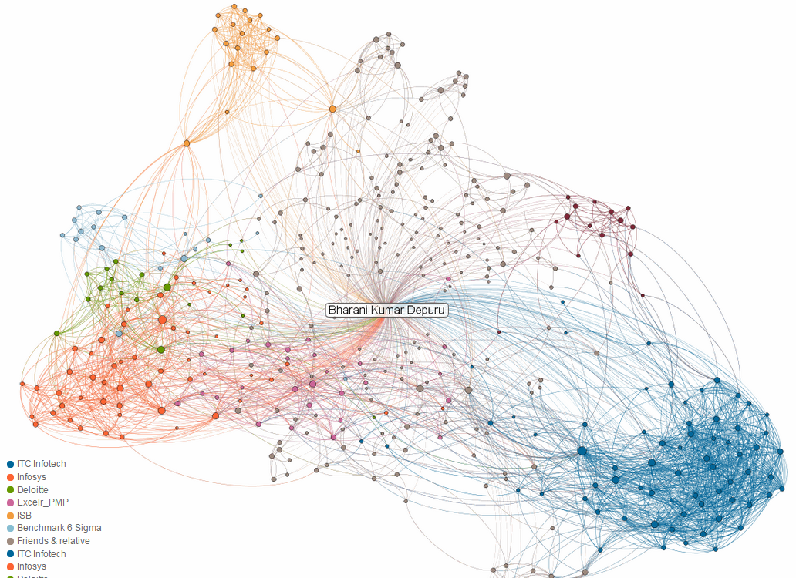

**CONTACT CHAINING**

http://www.economist.com/news/special-report/21709773-who-benefiting-more-cyberisation-intelligence-spooks-or-their

**Slide-2**

Preliminaries of Network

**Graph/network** G = (V, E)

Edges / Links

Vertices / Nodes

**V: {v1, v2, v3,…...vn}**

**E: {e1, e2, e3,…...en}**

**e1: vi -> vj , e2: vj -> vk,....................**

**Slide-3**

**Adjacency Matrix**

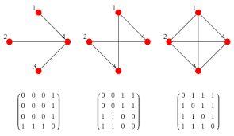

* FB network is *bidirectional*
* Twitter network is *unidirectional*
* For undirected graph, adjacency matrix is symmetric
* Edges can be listed in this way



**Slide-4**

**Social Status**

How much can we pay to the celebrities for the tweets?

How much are the celebrities worth or how much do they impact the customers?

<http://www.wetpaint.com/how-much-do-celebrities-get-paid-to-tweet-663232/>

**Slide-5**

**Networks beyond Social Media Network**

Network of research collaboration

* Nodes: Researchers
* Edges: Link between researchers when they work on the same project

**Network of actors**

* Nodes: Actors
* Edges: How to link actors
* Co-actors in a movie
* Work on similar genres
* Works with same director
* Were seen in the same party

**Slide-6**

**Peer-to-peer network**

Who is a better candidate to lend credit?

Does peer-to-peer lending network has any information





These 5 biggest platforms are generating over $10 Billion every year

<http://www.economist.com/news/special-report/21650289-will-financial-democracy-work-downturn-people-people>

**Slide-7**

**Network Description**

* Node Properties
* Edge Properties
* Network Properties

**Slide-8**

**Node Properties**

* Degree Centrality
* Closeness Centrality
* Page Rank
* Eigenvector Centrality
* Betweenness Centrality

**Slide-9**

**Degree Centrality**

* Number of direct ties with other nodes
* A local measure

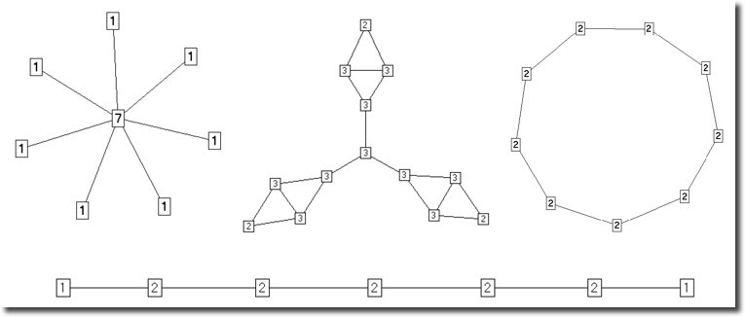

**Slide-10**

**Closeness Centrality**

* How close the node is to all other nodes in the network
* Closeness = 1/(sum of distances to all other nodes)
* Normalized Closeness = (Total no. of nodes - 1) * Closeness

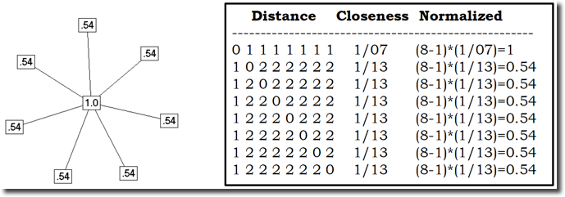

**Slide-11**

**Eigenvector Centrality**

* Measure “who” a node is connected to
* High-scoring nodes contribute more to the score of the node in discussion than equal connections to low-scoring nodes

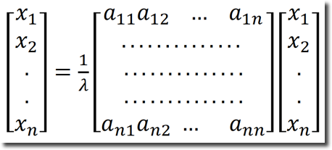

**Slide-12**

**Google PageRank Algorithm**

* A page is important if many other pages point to it
* Not all pages that point to it are treated equally
* Takes into account the importance of that page (PageRank) & how many pages it points to

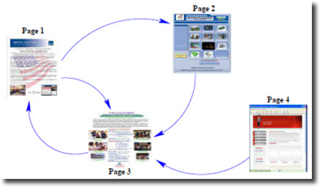

* These equations provide pis, where pi is rank of the Page i
* (1-d) is the probability that someone doesn’t click on a link; but jumps instead to a random webpage
* Apparently ‘d’ is set to 0.85

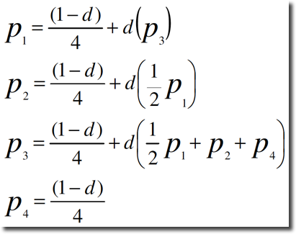

**Slide-13**

**Betweenness Centrality**

**Applicable for both Vertex & Edge**

**Betweenness**

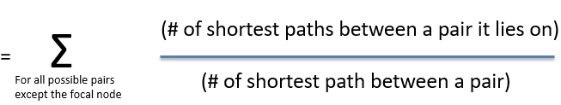

Normalized Betweenness **=**

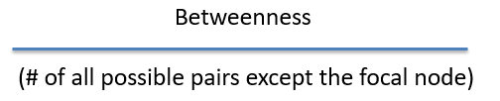

# Of all possible pairs except the focal node = [(n-1) * (n-2)]/2

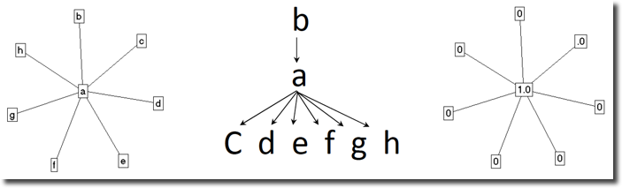

**SLIDE-14**

**Egocentric Network**

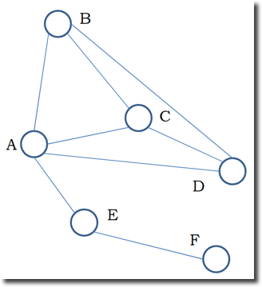

Original Network

Degree 1 Egocentric network of A

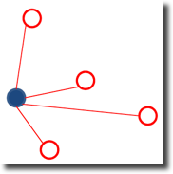

Consists of all the edges & nodes connected to the focal node

Degree 1.5 Egocentric network of A

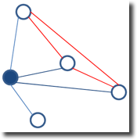

Degree 1 egocentric network + all edges of the nodes in Degree 1 egocentric network

Degree 2 Egocentric network of A

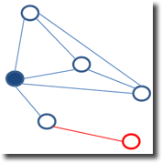

Degree 1.5 egocentric network + all edges & nodes connected to Degree 1.5 egocentric network

**SLIDE-15**

**Egocentric Network - Applications**

* Focuses on an individual
* The egocentric network of an individual can be the predictor of economic success, happiness or depression, access to opportunities, health, etc.?
* Egocentric network can be constructed based on not only social network but other transactional relationships, as well

**Slide-16**

**Network related properties**

* **Path**
* **Diameter**
* Largest of the shortest paths among all pairs of nodes
* **Cluster Coefficient**

# Of links that exist among its neighbors

# Of links that could have existed among its neighbors

* Measures the degree to which nodes in a graph tend to cluster together
* **Shortest path**

Average of the shortest paths among all pairs of node

**Slide-17**

**Applications of cluster coefficient**

**•** Increase in the cluster coefficient in interaction in a classroom

– Formation of communities

• Change in shortest path, accounting for traffic, from Point A to Point B, during the time of the day in Google map

**Slide-18**

**Airline network**

* Which airport has most flights coming in?
* Which airport has most flights going out of?
* Which airports are easiest to reach (has more connectivity) from most part of the world?
* Which airport comes in between most of the routes and hence is an important international hub?
* Which is the most well known airport in the world (the Google way)?

**Slide-19**

**Link Prediction**

**Recommender Systems**

Predicting links between users & items within a user-item bipartite graph representing preferences or purchases

**Information Retrieval**

Prediction of links between words and documents within a word-document bipartite graph representing word occurrence

**Targeting Intelligence Surveillance**

Start with known targets, and then use link prediction to identify individuals requiring surveillance

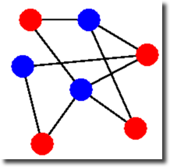 **🡪 Bipartite Graph**

## **Slide-20**

## **Applications**

## 